Name :-Akshat Jain

Section CS 6A

Roll No:- 2200290120019

Set A:-

# 1. TCP Echo Server and Client Server (echo_server.py):

Client (echo_client.py):

Computer Network Lab Lab External

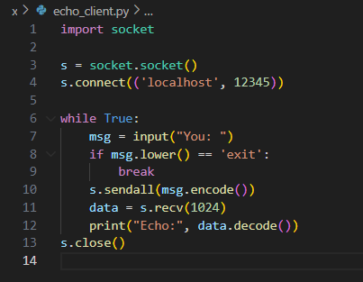

Set B;

Layered OSI Model Demo

Use a PC and server in Packet Tracer. Transfer a file or use ping.

Use the Simulation Mode to view packet movement across OSI layers.

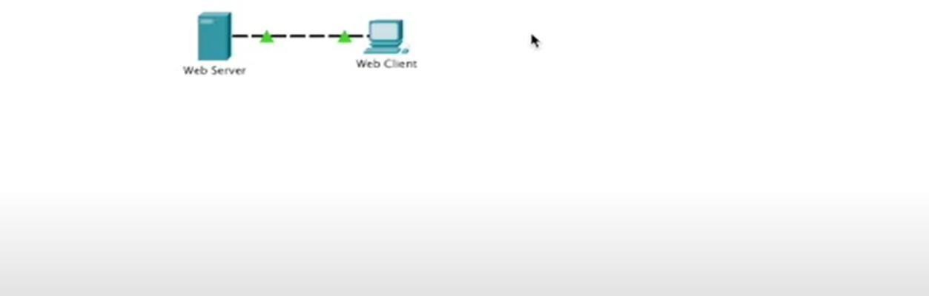

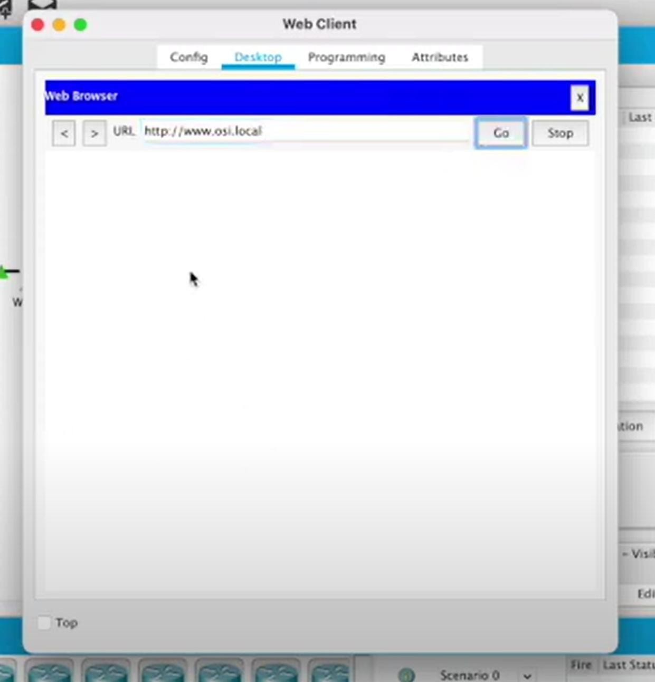

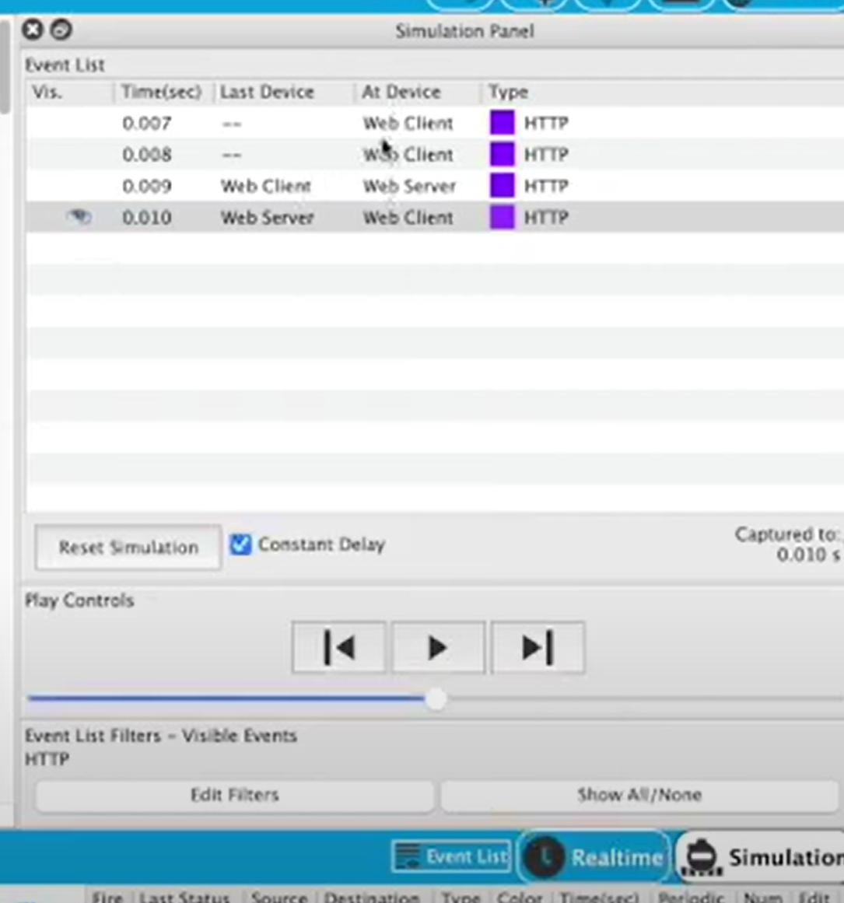











# Final Outcome:

The **ping will succeed** if IPs are configured correctly.

You’ll be able to **track the packet journey through all OSI layers**, fulfilling your lab objective.